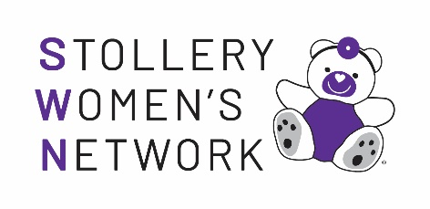

SWN Advisory & Committee
Volunteer Application Form

Name:
Address:
Phone: | Email:
Stollery Children’s Hospital or Foundation Involvement:
Role you are applying for:
Bio and/or resume (300 words)
*Please submit resume if available.

KNOWLEDGE, SKILLS & ABILITIES
□ Community Leadership/Influence
□ Ability to Juggle a Million Tasks at Once (Mom Skills!)
□ Board Leadership
□ Communications
□ Fundraising
□ Governance Experience
□ Human Resources
□ Marketing / Public Relations
□ Political Expertise
□ Other (Specify)

(Check those that apply)

Why are you passionate about the Stollery?

___Yes, I give my express consent to receive emails from the Stollery Children’s Hospital Foundation and its affiliates.

